Fleet Management Solutions

Optimize your fleet and keep costs down

Dynamic growth of automotive branch enables greater access to means of transport. Most companies have smaller or larger, vehicle fleet to carry out various tasks. Understanding costs related to the vehicle maintenance, fuel consumption, driver performance, insurance and service is an important function for any business.

Our Platform Is a cloud-based solution with a complete set of remote management services, fleet tracking, asset tracking and a variety of vertical applications.

As an off-the-shelf turnkey solution, our platform is secure, open and scalable and plays a key role in enabling visibility, facilitating management and optimizing resource utilization.

[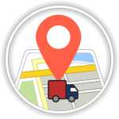](https://www.trackeez.com/)

[**REAL TIME / LIVE TRACKING**](https://www.trackeez.com/)

The Real time location of your vehicles can be tracked with the Trackeez GPS Tracker.

[](https://www.trackeez.com/)

[**GEOFENCE AND LANDMARKS**](https://www.trackeez.com/)

A Virtual boundary in terms of fencing can be created to and alerts can be sent when your vehicles enters or leaves a particular Area / Locality.

[](https://www.trackeez.com/)

[**ALERTS & NOTIFICATION**](https://www.trackeez.com/)

Alerts & Notification will be received on various activities.If your chauffeur takes the vehicle to some unwanted area and stops responding to your calls. It can be done through App or SMS.

[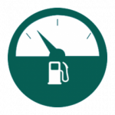](https://www.trackeez.com/)

[**FUEL AND MILEAGE MONITORING**](https://www.trackeez.com/)

With the Fuel and Mileage monitoring feature of our GPS Tracking solution, you can get to know the fuel consumption and fuel-in status of your vehicle.

[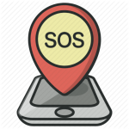](https://www.trackeez.com/)

[**SOS & PANIC BUTTON**](https://www.trackeez.com/)

The SOS alarm button can trigger a SOS call to mobile numbers or directly to a 24/7 security

[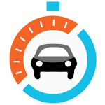](https://www.trackeez.com/)

[**SPEED MONITORING ON GRAPH**](https://www.trackeez.com/)

The Speed of the vehicle can be regularly tracked to ensure the vehicle safety and maintenance

[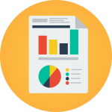](https://www.trackeez.com/)

[**ACTIVITY REPORT**](https://www.trackeez.com/)

All Activity Reports can be stored into the device through the data received by GPS  in graphical form which are easy to understand and implement in the business

[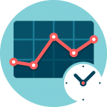](https://www.trackeez.com/)

[**HISTORY LOG**](https://www.trackeez.com/)

The Data for the activity is stored which can be downloaded for all future references.